KPC PUBLIC SCHOOL KHARGHAR
Assessment – IV (2022 - 2023)

GRADE : VI MARKS : 50 SUBJECT : MATHS TIME: 2 HRS

Q.1. Choose the correct option (6 M)
1. Two intersecting lines intersect at ______ .
(a) 1 point (b) 2 points (c) 3 points (d) 4 points
2. A page is 25 cm long and 20 cm wide. Find the perimeter of this page.
(a) 90 cm (b) 45 cm (c) 500 cm (d) 5 cm.
3. Between which two whole numbers on the number line does the number 3.3 lie?
(a) 0 and 1 (b) 1 and 2 (c) 2 and 3 (d) 3 and 4.
4. What is the method of finding a solution by trying out various values for the variable called?
(a) Error method (b) Trial and error method
(c) Testing method (d) Checking method
5. 5g = ______
(a) 0.005 kg (b) 0.05 kg (c) 0.5 kg (d) none of these
6. Find the area of square S = 13 cm
(a) 169 sq.cm (b) 166 sq.cm (c) 165 sq.cm (d) 164 sq.cm
Q.2. Solve the following (5 M)
1. Arrange the following numbers
a. In Ascending order 0.01, 0.001, 0.1, 1
b. In Descending order 1.234, 2.341, 3.421, 0.1234
2. Write the equations for the following statement
The sum of three consecutive integers is 27.
Solution:
Let the three consecutive integers be ____ , x and _____ .
Sum of three consecutive integers = ___
Then, _____ + x + _____ = ___
____ + x + x + 1 = 27
So, ___ x = 27
3. Find the perimeter of the following figures
a. Length = 5.9 m and Breadth = 4.3 m
l = 5.9 m
b = _____
Perimeter of rectangle = ______
= __ (5.9 + __ )
= 2 × ___
= ____
Ans. Perimeter of rectangle is _____ .
4. Sharon’s height is 145.62 cm. She stands on a tool of height 10.50 cm. What is the combined height now?
Solution:
Sharon’s height is ______ .
She stands on a tool of height ______ .
What is the combined height now?
= Sharon's height + _______
= 145.62 + ______
= ________
Ans. Sharon's combined height is _______ .
Q.3. Solve the following (9 M)
1. Solve the following equations using method of balancing.
a. - 6m = 12 b. y - 13 = - 12
2. Draw any six- sided polygon and name the following
a. Its sides. b. Its vertices. c. Its adjacent sides
3. Find out the cost of clearing a rectangular piece of land which is 32 m long and 20 m wide. The rate for clearing is 2.25 per sq. m.
Q.4. Solve the following (Solve any 3) (12 M)
1. Convert the following using decimals
a. Convert 9 kg 2 g into kilograms using decimals.
b. Convert 5678 m following into kilometres using decimals
2. A mountaineer climbs 72.32 metres from the base camp situated at an altitude of 3275.33 He climbs another 35.86 metres in the second stage. What altitude would he have reached after this?
3. Simplify the following
a. 17.92 - 5.868 + 18.931 - 0.15 b. 6.007 + 7.006 + 21.010 + 1.020
4. Solve the following equations using trial and error method.
a. 4x/3 = 4 b. 2x + 5 = 15
Q.5. Solve the following (Solve any 3) (15 M)
1. In the adjoining figure, ABCD is a quadrilateral.
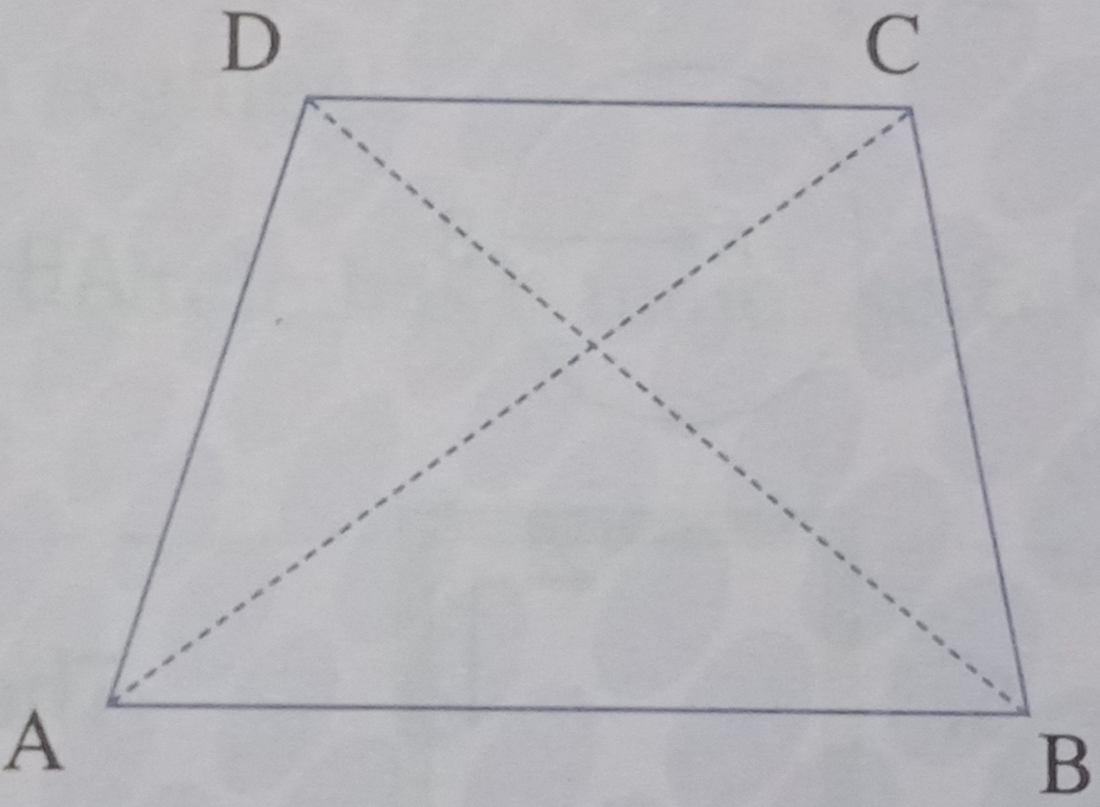
a. How many pairs of adjacent sides are there? Name them.
b. How many pairs of opposite sides are there? Name them.
c. How many pairs of adjacent angles are there? Name them.
d. How many pairs of opposite angles are there? Name them.
e. How many diagonals are there? Name them.
2. The odometer in a car reads 10234.650 km at the starting point in Mumbai, on a trip of 220.550 km to Pune. The journey is cut off by 111.067 km before Pune at Lonavala. What will be the odometer reading at Lonavala?
3. A dance floor is 35 m long and 26 m wide. Find out its area and perimeter. How much would it cost to do a mosaic flooring, if it costs 23.40 per square metre?
4. Radha walked 12 m, 15 m and 13 m to go around a field. Priya walked around another field where she walked 45 m to cover all the 4 sides.
a. Find out the shapes of the two fields they walked around.
b. Who walked more distance?
c. What is the formula to find out the distance walked around each of the fields?

